To be able to receive email notifications when your direct reports get an award, including the “High Five”, please follow the instructions below:

Go to the ***BraVo***! Landing page and click on the triangle next to your name (in this case *AeroVironment Recognition*): <https://aerovironment.awardco.com/welcome>

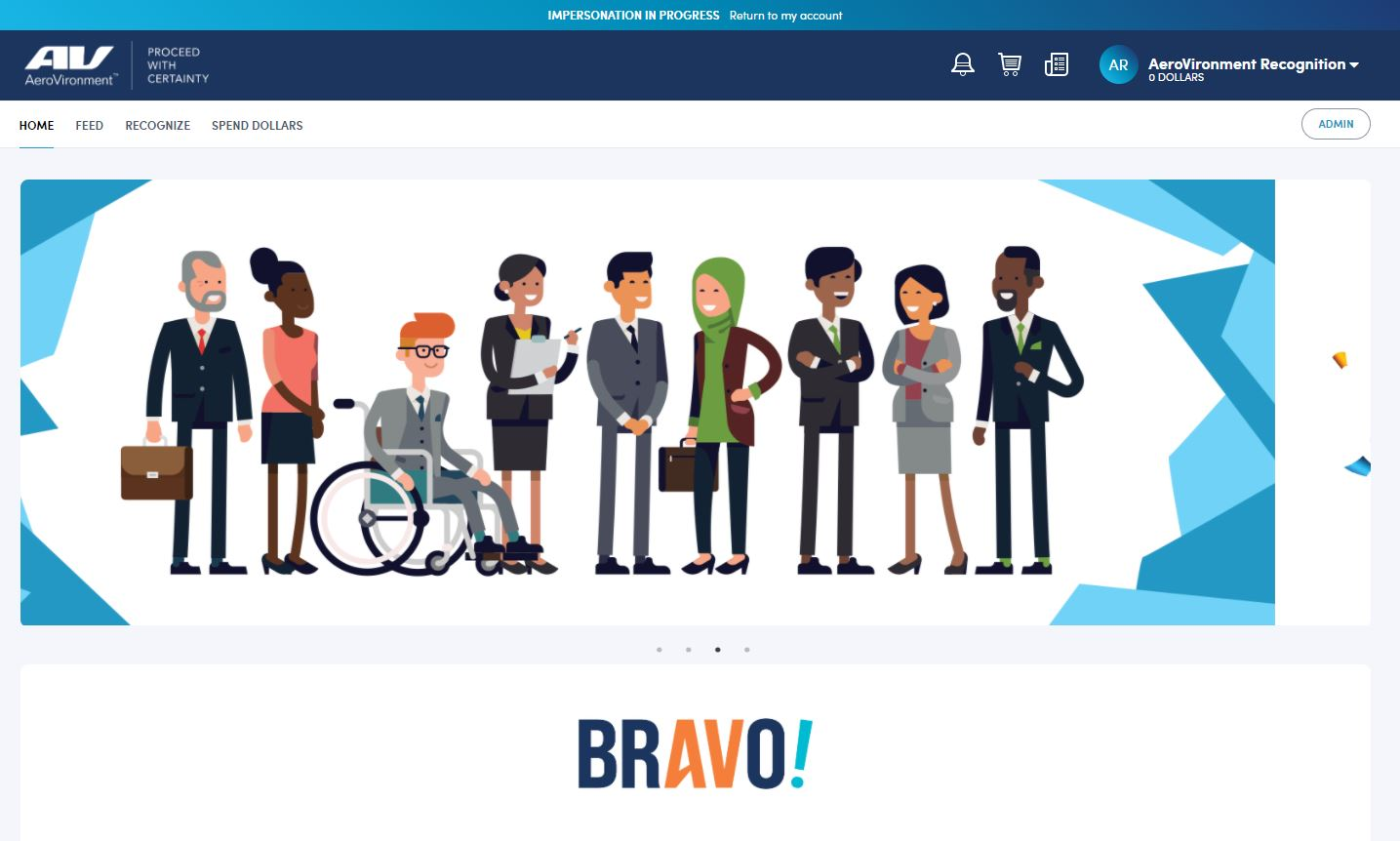

Click on ***My Account***

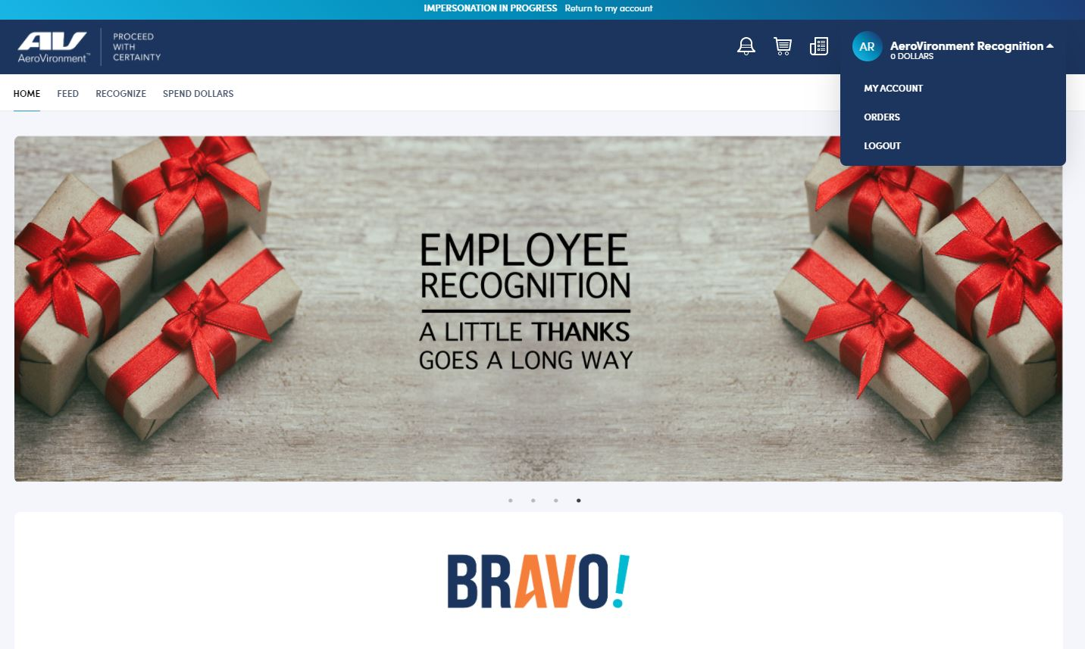

Click on ***Notifications***, then select ***Direct Reports***

