Employee and Manager Instructional Guide
Employee Self Service| Time off Request

Employee Instructions:
- To request for time off for a future date, access the option for Time Off Request
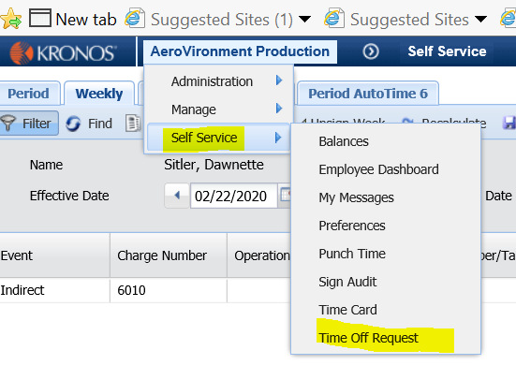

- Add an event:
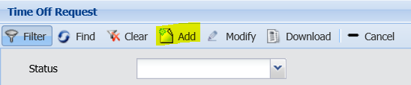

- Select the Event type:
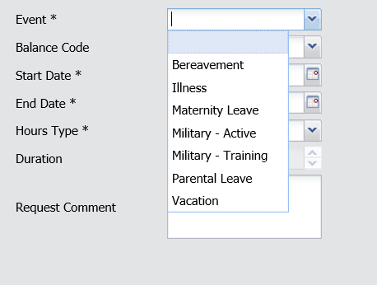

- Enter the dates for which you will need time entered.
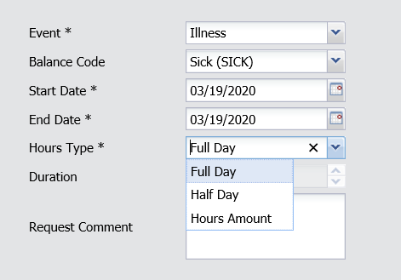

- Select the appropriate Hours Type:
- Full Day will enter hours based on your normal schedule (8 or 9 hours)
- Half Day will enter a half days hours based on your schedule (4 or 4.5)
- Hours amount will require you to enter the number of hours you wish to charge for each day in the range entered. Parental, Maternity, Military, Military Training and Bereavement time must be added to the bank by P&C before it is accessible.
NOTE: When coordinating pay during a leave of absence, you will need to contact P&C Benefits to determine the correct amount of hours to use.
Note: Autotime will not enter hours on an unscheduled workday. Therefore, it is not necessary to enter multiple request unless you are changing the number of hours you want recorded.

Manager Self Service| Approving a Time off Request

Manager Instructions:
- Managers will receive an email from sqlmail with the subject “Employee PTO Request” notifying you of the request for review/approval.

- Log into autotime and go to your manager view and Time off Review:
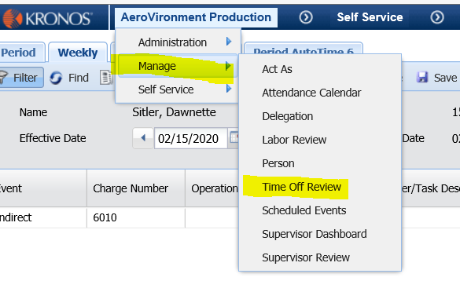

- From this screen you will see the request(s) from your employee(s) for review and approval. Highlight the request and select the appropriate response.
NOTE: if you do not take action on the request, the employee’s timecard will not be adjusted.

